Report

Milestone 3 - Software Market Research

Team Phyvve
Callissa Uccello, Arlena Ung
Emanuel Orduna-Chin, Sophia Ngo, Danny Lo
Professor: Fahd Albinali, PhD
California State University, Long Beach
College of Engineering
CECS 491A, Sec 03, Spring 2026

Table of Contents
Milestone 3 - Software Market Research 1
Table of Contents 2
Introduction 5
Refined Project Idea 5
Market Overview 6
Size and Growth 6
Major Players 6
Trends 6
Shift from Passive Prep to Active Simulation 6
Growth of Real-Time Tools 6
Gamification and Engagement 7
Resume and Job-Description Integration 7
Competitor Analysis 8
Sensei AI (https://www.senseicopilot.com/) 8
Overview 8
Hands-on Evaluation 8
First Impressions: 8
Usability and User Experience: 8
Standout Features: 8
Significant Gaps: 9
Features & Offerings 9
User Reviews & Ratings 10
Final Round AI (https://www.finalroundai.com/) 10
Overview 10
Hands-on Evaluation 10
First Impressions: 10
Usability and User Experience: 10
Standout Features: 11
Significant Gaps: 11
Features & Offerings 11
User Reviews & Ratings 12
Verve AI (https://www.vervecopilot.com/) 12
Overview 12
Hands-on Evaluation 12
First Impressions: 12
Usability and User Experience: 13
Standout Features: 13
Significant Gaps: 13
Features & Offerings 13
User Reviews & Ratings 15
Opportunity Assessment 16
SWOT Analysis 16
Gap Analysis 17
Strategic Positioning 18
Differentiation 18
Differentiation Matrix 18
Challenges 19
Conclusion 21
Appendices 22
Competitor Feature Comparison List 22
Detailed User Reviews 23

Introduction
We are developing an AI-powered interview preparation platform designed to reduce interview anxiety and build genuine confidence among job seekers. Building on findings from our user-centered research in Milestone 2, this report examines the competitive landscape for AI-driven interview tools, quantifies market opportunity, and identifies strategic positioning for our product.

Refined Project Idea
Our platform conducts personalized mock interviews through voice, chat, and video interaction. Core capabilities include
- Real-time, AI-generated feedback on content, clarity, and pacing
- Resume integration to tailor questions to the user’s specific background
- An interview calendar that ramps difficulty as interview dates approach
- Industry-specific question sets including a dedicated coding sandbox for technical roles
- A gamified achievement system to sustain motivation throughout the job search
- Video mode with transcription and buzzword analysis
- A tiered subscription model:
  - Free (5 mock interviews/month)
  - Standard ($10/month)
  - Premium ($15/month)

Market Overview

Size and Growth

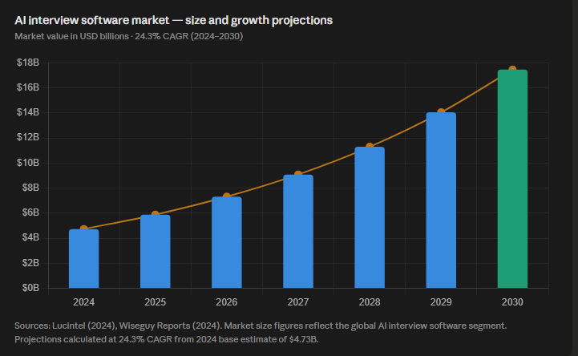
- AI interview software market projected to grow from ~$4.7B (2024) to ~$17B (2030)
- 24%+ annual growth rate (CAGR)
- Growth driven by remote hiring and AI adoption
- Increasing demand for personalized interview preparation

Major Players

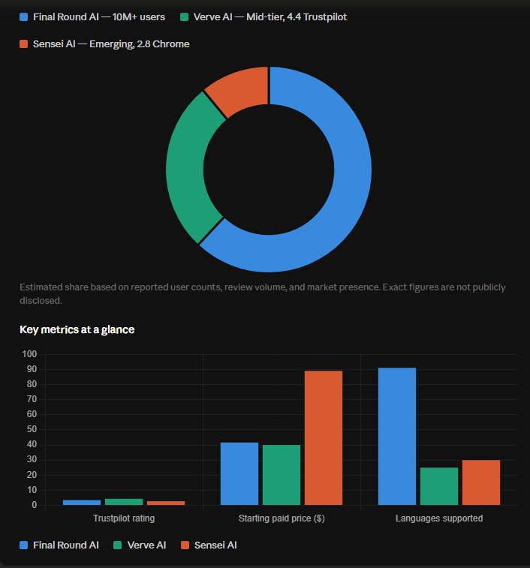

Trends

Shift from Passive Prep to Active Simulation
Users are increasingly dissatisfied with static resources like YouTube videos and practice question lists. The market is moving toward interactive, real-time tools that simulate the pressure of actual interviews. This trend was independently validated by our own user research in Milestone 2.

Growth of Real-Time Tools
A dominant category of competitors — including Sensei AI, Verve AI, and Final Round AI — have pivoted toward live interview assistance: AI that listens during an actual interview and suggests answers in real time. While effective at helping candidates 'survive' an interview, these tools raise ethical concerns and do not build lasting skills.

Gamification and Engagement
Consumer-facing ed-tech and career tools are increasingly incorporating gamification to improve retention. Platforms that reward consistent practice tend to see higher engagement, a pattern we are designing for with our achievement system.

Resume and Job-Description Integration
The most effective tools personalize practice sessions to the user's specific resume and job description, rather than serving generic questions. This is now a baseline expectation among users and a feature we are building into our core offering.

Competitor Analysis

Sensei AI (https://www.senseicopilot.com/)

Overview
Sensei AI is a browser-based real-time interview copilot. It integrates with Zoom, Microsoft Teams, and Google Meet, listens to live interview audio, and provides instant, structured answers on-screen. It supports 30+ languages, includes a coding copilot for technical interviews, and allows users to upload their resume for personalized responses.

Hands-on Evaluation

First Impressions:
The onboarding experience requires users to create detailed profile information including resume and behavioral background. The interface is clean and minimalist, though the Chrome tab based display can obstruct the interview screen during live sessions.

Usability and User Experience:
Has fast response speeds and high-quality behavioral answers that feel personalized. However, answers can sound AI-generated, requiring editing, and the movable overlay window can disrupt the interview flow. The copilot feature is not always easy to discover within the interface.

Standout Features:
Real-time voice detection, multilingual support, integrated coding copilot, resume-based personalization.

Significant Gaps:
Built as a live-interview safety net rather than a skill-building tool. The interview copilot provides personalized answers in real-time during an interview rather than helping them improve independently. Limited post-session analytics.

Features & Offerings
Plan | Price | Key Features
Free | $0 | - 15-min Copilot Sessions  - AI Resume Builder  - AI Story Editor
Pro | $89/month | - Unlimited Copilot Sessions  - AI Resume Builder  - AI Story Editor  - Full Customization Suite  - Industry Knowledge Base Add-Ons  - Coding Copilot  - AI Playground

User Reviews & Ratings


Final Round AI (https://www.finalroundai.com/)

Overview
Final Round AI is positioned as a premium, comprehensive interview preparation platform. It offers a live interview copilot, AI mock interviews with adaptive follow-up questions, performance analytics, and a resume builder. It is widely regarded as the most feature-complete tool in the live-copilot category and has reportedly supported over 1.2 million interviews.

Hands-on Evaluation

First Impressions:
Final Round Ai is positioned as a premium, comprehensive interview preparation platform. It offers a live interview copilot, AI mock interviews with adaptive follow-up questions, performance analytics, and a resume builder. It has undetectable real-time assistance during actual interviews, trusted by job seekers across 80+ countries, 91 languages and accents. They reportedly have 10+ million users worldwide.

Usability and User Experience:
The mock interview is strong. It generates adaptive follow-up questions that respond to user answers, making practice sessions feel more like real interviews. Detailed transcripts, performance scores, and coaching feedback are provided post-session.

Standout Features:
Best adaptive mock interview, comprehensive post-session reports, wide integration with video platforms, stealth mode in higher tiers.

Significant Gaps:
The pricing is the biggest complaint across user reviews; $100/month and a strict no refund policy. This makes it inaccessible to most students and early career job seekers. The tool is built primarily for people who already have interviews lined up, not for long-term skill development.

Features & Offerings
Plan | Price | Key Features
Free | $0 | - Unlimited mock interview  - AI interview report  - Access to interview question bank  - 3-day money-back guarantee
Premium | $100.00/month | Everything from Free Tier plus:  - Unlimited live interview copilot  - Stealth mode (desktop app)  - Coding/System design interview

User Reviews & Ratings
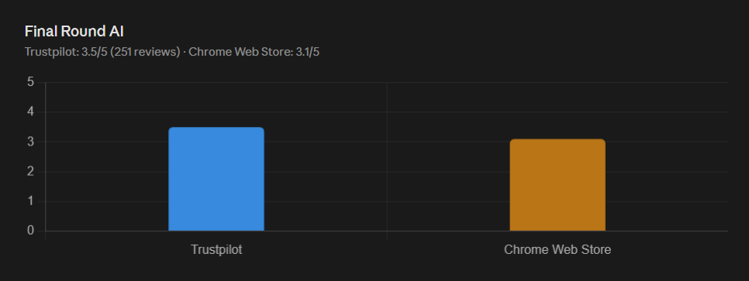

Verve AI (https://www.vervecopilot.com/)

Overview
Verve AI is a comprehensive, browser-based interview preparation and live assistance platform. It integrates with major video conferencing tools including Zoom, Google Meet, and Microsoft Teams, listening during live interviews to provide real-time, structured answer suggestions tailored to the user's resume and target role. Beyond live assistance, Verve AI offers a full suite of job search tools including AI mock interviews, a resume builder, a coding copilot for technical rounds, and an online assessment solver. It supports over 25 languages and uses a stealth mode designed to remain undetectable during screen sharing.

Hands-on Evaluation

First Impressions:
Verve AI's onboarding experience is polished and relatively straightforward, though it requires more initial setup than a purely browser-based tool. Users must create an account and configure their profile with a resume and job description before accessing the copilot. The platform's interface is feature-rich, which can feel overwhelming at first given the number of tools available including mock interviews, resume builder, coding copilot, and live assistance all compete for attention on the dashboard. The live copilot experience is smooth and the value proposition becomes clear: real-time, personalized answer suggestions during actual interviews without the interviewer being able to detect it.

Usability and User Experience:
This tool delivers real-time transcription with structured, role-specific responses. Behavioral answers follow the STAR format and the coding copilot provides working solutions for technical rounds. Response quality can occasionally feel generic, and speed trails behind faster competitors. Like most tools in this category, it functions more as a live safety net than a skill-building environment.

Standout Features:
Real-time answer suggestions during live interviews, stealth mode for undetectable use, AI mock interviews, coding copilot for technical rounds, resume builder, and support for 25+ languages.

Significant Gaps:
Feature depth can feel surface-level for some use cases — the live copilot occasionally produces generic responses that lack personalization. The free tier is limited, and pricing scales quickly for heavier usage. Despite its broad feature set, the platform has no structured progress tracking, and user reviews note that response speed and transcription accuracy trail behind top competitors.

Features & Offerings
Plan | Price | Key Features
Free | $0 | - Mock interview 5x  - AI interview report  - Basic copilot access
Standard | $16.99 | - Everything in Free plus unlimited live copilot  - Unlimited Mock Interviews  - Additional AI Tools
Pro | $34.99 | - Everything in Standard plus coding copilot  - 20 Interview Domains  - Unlimited Copilot Sessions

User Reviews & Ratings
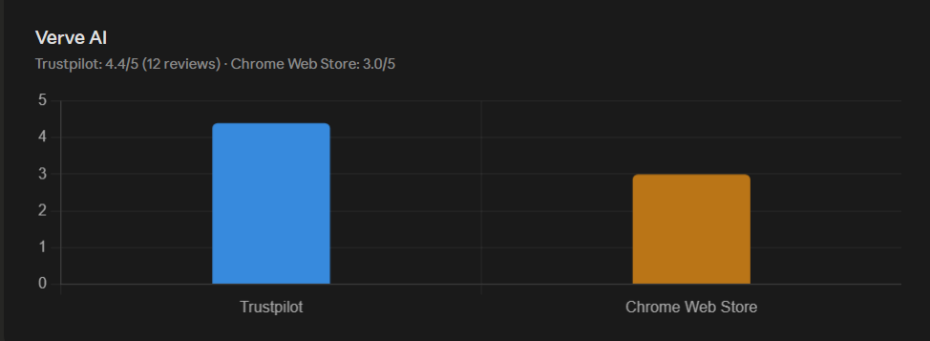

Opportunity Assessment

SWOT Analysis
Strengths  - Gamified achievement system for sustained engagement  - Dual practice modes: voice & chat interaction  - Resume integration & personalization  - Interview schedule calendar with adaptive difficulty  - Anxiety-reduction focus vs. pass/fail focus  - Tiered pricing including a free tier | Weaknesses  - No established brand trust  - Video body language analysis is complex to build  - Reliance on user-provided resume data quality  - No existing user base or reviews at launch
Opportunities  - Large, underserved population of anxious job seekers  - Growing remote interview adoption post-pandemic  - International candidate market & multilingual support  - Partnership potential with universities & career centers | Threats  - Ethical & academic integrity concerns around AI assistance  - Established copilots (Sensei AI, Final Round AI, Verve AI)  - Data privacy and GDPR compliance requirements  - Rapidly evolving competitor feature sets  - User over-reliance reducing long-term value perception

Gap Analysis

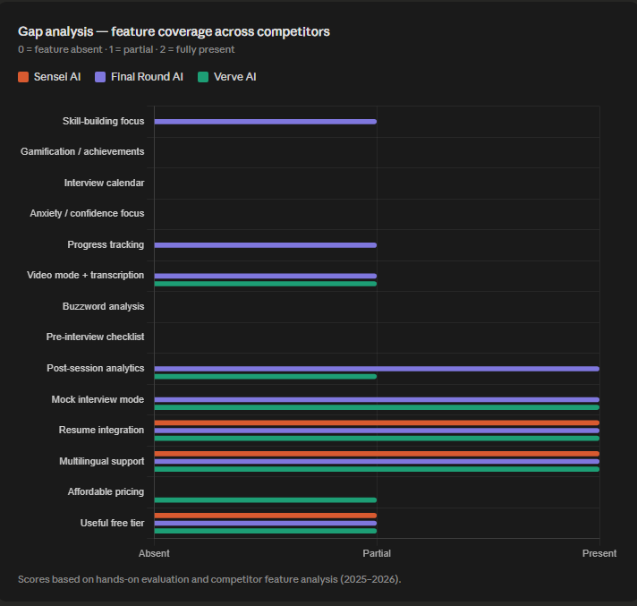

Strategic Positioning

Differentiation
Phyvve occupies a fundamentally different position in the market. While all three major competitors function as live interview assistants, Phyvve is a preparation and skill-development platform. We help users become better interviewers, not just survive their next one.

Our core differentiators are:
- Skill-building vs. answer-feeding: Phyvve builds genuine communication skills and confidence through structured practice, not real-time prompting.
- Gamification for sustained engagement: The only platform with a structured achievement and rewards system to keep users practicing throughout their job search.
- Timeline-aware preparation: The interview calendar dynamically adjusts practice difficulty as interview dates approach; a feature absent from all competitors.
- Anxiety as a first-class design concern: While competitors focus on passing interviews, we focus on reducing the fear that prevents users from performing at their actual ability level.
- Accessible pricing: At $10/month Standard and a genuinely useful free tier, Phyvve is the most affordable comprehensive preparation platform in the market.

Differentiation Matrix
Platform | Skill-Building Orientation (1-5) | Affordability (1-5, 5 = most affordable) | Strategic Position
Sensei AI | 2 | 2 | Live assist, mid price
Final Round AI | 3 | 1 | Premium mock interviews, mid-high price
Verve AI | 2 | 3 | Broad features, mid price
Phyvve | 5 | 5 | Skill-building, anxiety-focused, accessible

Challenges
Challenge | Mitigation Strategy
No existing user base or reviews | Partner with CSULB career center and similar university programs for early adoption; leverage student networks for beta testing
Ethical concerns around AI interview tools | Position Phyvve explicitly as a preparation tool, not a live cheating aid; publish clear usage guidelines and emphasize skill development in all marketing
Competing against free tiers from Verve AI | Differentiate on gamification, calendar, and the anxiety-reduction narrative that competitors do not address
Rapidly evolving competitor feature sets | Maintain a monthly competitive monitoring process; use user feedback loops to prioritize features that directly address the anxiety and confidence gap, where competitors are structurally uninterested in competing

Conclusion
This market research confirms that the AI interview preparation space is growing rapidly, projected to reach approximately $17B by 2030, and that dominant players like Final Round AI, Verve AI, and Sensei AI have now converged on a single position: live interview assistance. While effective at helping candidates survive an interview in the moment, these tools consistently fall short in skill development, emotional support, and accessible pricing. None offer gamification, an adaptive interview calendar, or an explicit focus on reducing interview anxiety which is a structural gap that existing platforms are unlikely to fill given their dependence on live-interview use.
Phyvve's positioning as a skill-building, anxiety-reduction platform is strongly supported by this research. Our pricing undercuts every major competitor while offering features unavailable at any competing price point, and our core differentiators (gamification, resume integration, and adaptive scheduling) directly address the gaps identified across all three competitors. The primary risks are brand trust and market education as a new entrant with no existing user base, and the need to clearly distance Phyvve from the ethical concerns surrounding live-copilot tools.
Based on this research, we recommend the following next steps: partnering with the CSULB career center to seed an initial user base, prioritizing gamification and the interview calendar in the MVP as our clearest differentiators, developing explicit messaging around Phyvve's skill-building mission to address ethical questions proactively, and conducting usability testing with students and early-career job seekers to validate the anxiety-reduction framing before launch.

Appendices

Competitor Feature Comparison List
Feature | Sensei AI | Final Round AI | Verve AI | Phyvve
Live Interview Assistance | Yes | Yes | Yes | Yes
AI Mock Interviews | Limited | Unlimited | Yes | Yes
Resume Integration | Yes | Yes | Yes | Yes
Adaptive Difficultity | No | Partial | No | Yes
Gamification/Achievements | No | No | No | Yes
Interview Calendar | No | No | No | Yes
Video Mode + Transcription | No | Partial | No | Yes
Buzzword Analysis | No | No | No | Yes
Progress Tracking | Limited | Yes | No | Yes
Anxiety/Confidence Focus | No | No | No | Yes
Pre-Interview Checklist | No | No | No | Yes
Free Tier Available | Limited Trial | Yes | Yes | Yes
Starting Paid Price | $24/month | $100.00/month | $16.99/month | $10/month

Features
Mock Interview
- Chat-based mock interviews with AI follow-up questions
- Voice-based mock interviews
- Video mock interviews (timed, recordable for self-review, with transcription)
- Industry-personalized questions (e.g. coding sandbox "Code Box" for software roles, scenario-based for customer service, etc.)
- Adaptive difficulty that adjusts based on performance
- Real-time feedback on clarity, delivery, response structure, and communication effectiveness
- Filler/buzz word detection and filtering
- Answer pacing analysis
Resume Integration
- Resume upload and parsing
- Personalized question generation based on resume content
- Job description matching — tailors resume suggestions to specific roles
- Suggestions to better emphasize work experience
Interview Schedule & Calendar
- Calendar view to log upcoming interview dates
- Difficulty ramping based on time proximity to interview date
- Pre-interview checklist
Progress Tracking & Gamification
- Achievement/reward system for completing practice sessions
- Performance-based badges and milestones
- Post-interview reports summarizing performance
- Progress tracking over time (confidence trends, improvement metrics)
AI Chat Assistant
- Conversational AI available throughout the app for guidance, tips, and prep support
- Judgment-free space for open-ended practice and questions
User Personalization
- Role and industry selection during onboarding
- Experience level settings (entry-level, mid-career, career changer, etc.)
- Customizable interview focus areas (behavioral, technical, competency-based)
Monetization Tiers
- Basic (Free): 5 mock interviews/month, chat only, basic text feedback
- Standard ($10/mo): Unlimited interviews (voice + chat), detailed feedback, resume integration, achievement system
- Premium ($15/mo): Video practice with body language analysis, company-specific prep, advanced analytics

Competitors
Market Analysis: Competitor overview, potential market size
Sensei AI
    - Pros: Good for interview prep progress tracking
      - Browser approach is simple, quick setup
      - Supports 30+ languages
      - Story Studio feature and built-in resume builder
    - Con: confusing to find copilot feature
      - Free session capped at 15 minutes
Verve AI
    - Persona based setup for specific roles
    - Con: confusing launch flow with misleading options
Interview CoPilot
    - Simple and straightforward concept
    - Con: bare minimum features
Potential market size
    - https://finance.yahoo.com/news/ai-assistant-market-reach-usd-073200487.html
      - The title is “AI Assistant Market to Reach USD 46.50 Billion by 2032, Driven by Enterprise Adoption, NLP Advancements, and Workflow Integration | Research by SNS Insider“
  - Competitors focus on passing the interview, but we emphasize creating a safe space to fail, learn, and improve at your own pace. While others offer static questions, we adjust difficulty based on performance progression. It keeps users engaged throughout their entire job search journey with rewards. Our application is not solely a performance tool, but an anxiety detection tool that builds genuine confidence.

Visuals
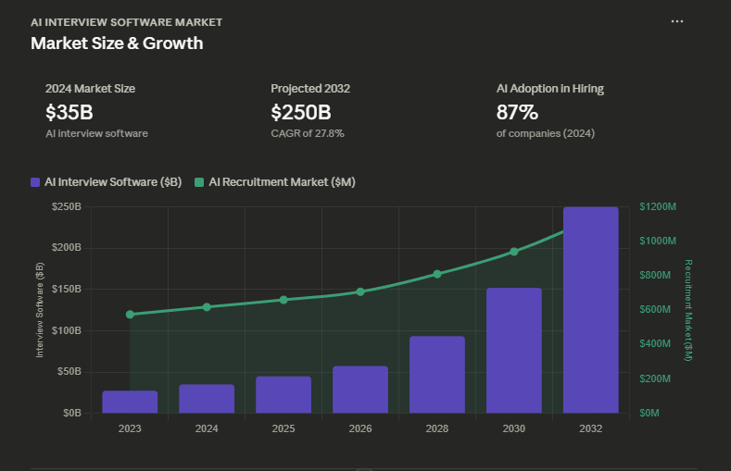
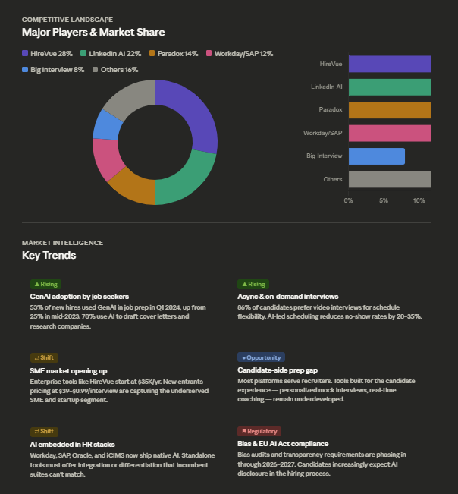
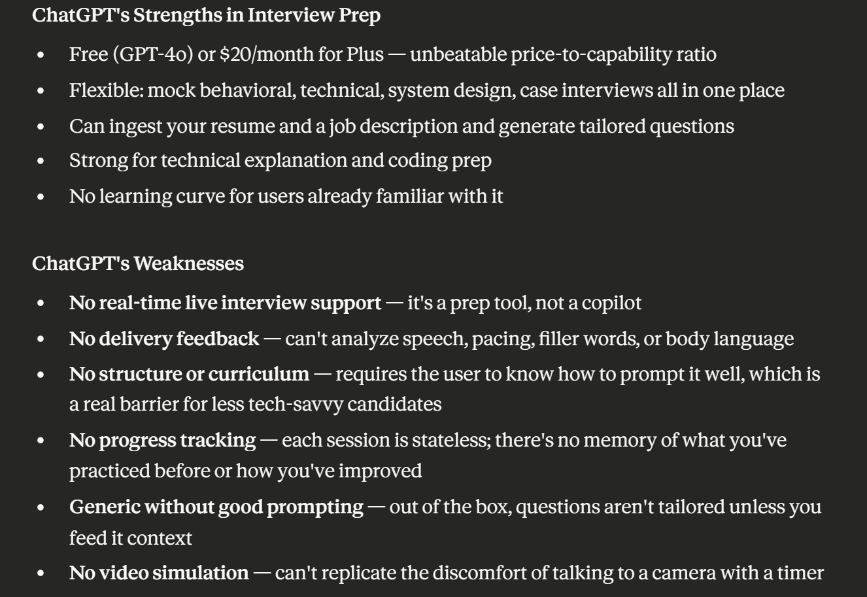

1. HireVue
Overview: HireVue is the dominant enterprise platform for AI-powered video interviewing and candidate assessment. HireVue's system allows candidates to record video or game-based interviews which are then evaluated by AI for attributes and competencies — nearly 20 million video interviews and assessments were conducted on its platform in just Q1 2024. It's used by JPMorgan, Goldman Sachs, IBM, Boeing, and hundreds of Fortune 500 companies. Importantly, HireVue is a recruiter-side tool — candidates are screened, not coached.

2. Big Interview
Overview: One of the most established candidate-facing prep platforms on the market. Big Interview uses AI to simulate interviews and offers AI mock interviews, resume and answer builders, structured video lessons, and written guides — all in one platform. It's widely adopted by university career centers and individual job seekers. Pricing sits at $39 for one month, $99 for three months, or a one-time payment of $299 for lifetime access. Its main limitation is that it doesn't support coding or system design questions, making it unsuitable for technical roles in software engineering or data science.

3. Final Round AI
Overview: Launched in 2023, Final Round AI is an all-in-one AI job search and interview assistant offering tools that automate job applications, CV building, and interview preparation, positioning itself as a premium solution for serious jobseekers. Its flagship feature is a real-time Interview Copilot that whispers answers during live interviews. However, it's controversial — users report detection during screen sharing, robotic responses, aggressive billing practices, and zero refund policies. Pricing runs $148/month on a monthly basis, dropping to around $81/month when billed semi-annually.

4. Google Interview Warmup
Overview: Interview Warmup was designed for Google Career Certificate learners and lets you practice answering questions selected by industry experts, using machine learning to transcribe your answers and help you discover ways to improve. It's completely free and requires no sign-up. It provides insights on pacing, word choice, and clarity — but doesn't grade answers or tell you what's right or wrong. Its biggest limitation is depth — it's a warmup tool, not a comprehensive prep system, and it hasn't received major updates recently.

5. Yoodli
Overview: Yoodli AI focuses on the often-overlooked communication aspects of interviewing, providing detailed analytics on speaking patterns and delivery — think filler words, pacing, eye contact, and tone. It asks contextual follow-up questions based on your answers and generates a speaking report with analytics and improvement suggestions. It's best for candidates who already know their content but need to polish their delivery. Pricing is free for up to 5 roleplays, then $20/month for premium. Its weakness is narrow scope — it doesn't cover technical prep or content quality.

6. Interviews by AI
Overview: Interviews by AI leverages GPT-4 to deliver hyper-realistic interview questions and answers along with actionable feedback, designed specifically to make the job interview experience less stressful. It's a lean, low-cost tool aimed at general job seekers. The free plan gives 3 questions per month, while the Pro plan is $9/month for unlimited questions and resume upload. It's approachable but thin on depth — no video analysis, no technical prep, and limited personalization beyond job title input.

Report Outline
Introduction

Project Overview

Background and Context

Market Overview

Market Definition
- industry/market we are analyzing
- Scope (geographic/demographic, etc)

Size and Growth
- Current market size
- Growth rate
- Future projections

Major Players
- List of key companies
- Brief description of each

Trends
- Key trends shaping the market
- Observations about shifts in user behavior or technology

Competitor Analysis

List and Overview of Competitors

Individual Competitor Breakdowns:
Competitor #1
- Overview
- Target audience
- Pricing model
Hands-on Evaluation
- First impressions:
- Usability:
- User experience:
- Strengths:
- Weaknesses:

Features and Offerings Comparison:

Feature | Competitor 1 | Competitor 2 | Competitor 3 | Your Project
Feature A
Feature B
Feature C

User Reviews and Ratings
- Summary of user opinions
- Common complaints
- Common praises

Gap Analysis
- What competitors are missing
- Unmet user needs

Strategic Positioning
- Your project’s role in the market
- Target niche
- Value proposition

Differentiation and Challenges

How our Project Stands Out
- Unique features
- Competitive advantage

Challenges and Solution
- Challenge 1 -> strategy
- Challenge 2 -> strategy

Conclusion
Key Findings
- Summary of insights

Implications
- What this means for our project

Next Steps
- Recommended actions

